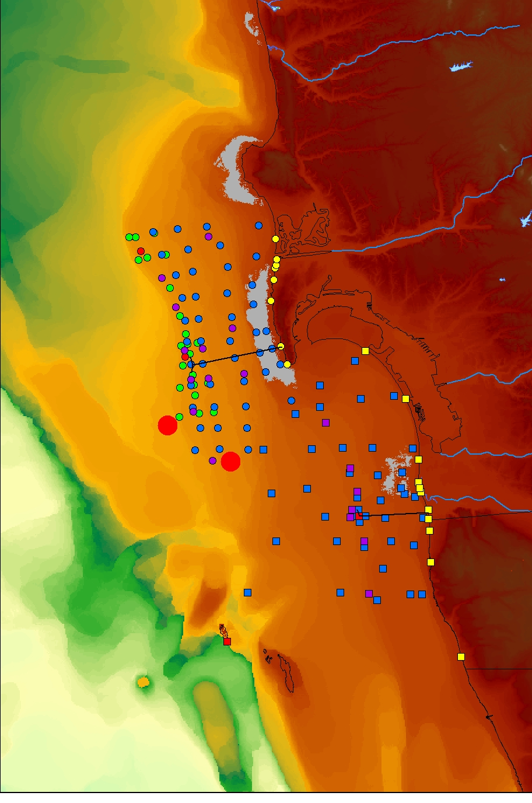

Point Loma Outfall Project
Report by
Scripps Institution of Oceanography
University of California, San Diego

To City of San Diego
Metropolitan Wastewater Department
UCSD Contract 2003-5378
September 2004

